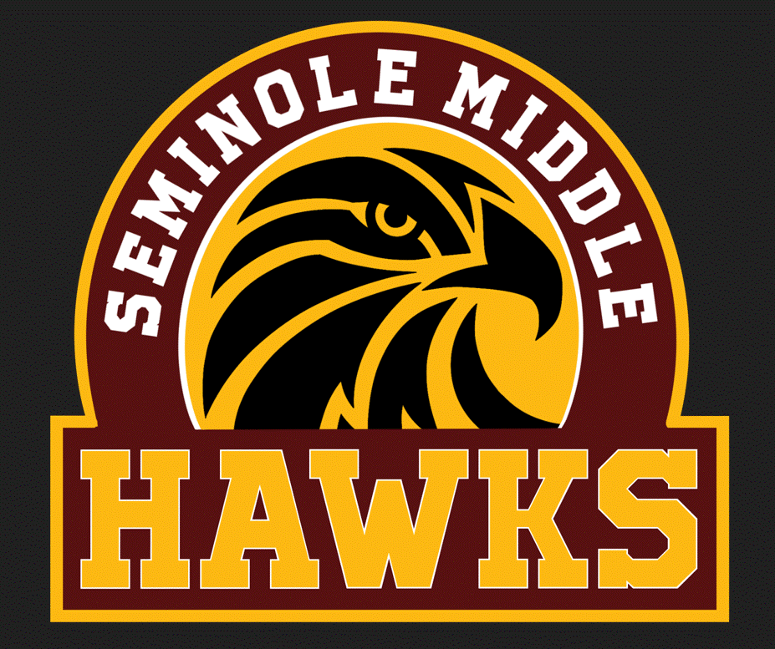
Seminole Middle School Bell Schedule 2023-2024

1st Lunch |  | 2nd Lunch |  | 3rd Lunch
1 | 9:40 – 10:32 | 1 | 9:40 – 10:32 | 1 | 9:40 – 10:32
2 | 10:36 – 11:26 | 2 | 10:36 – 11:26 | 2 | 10:36 – 11:26
L | 11:30 – 12:00 | 3 | 11:30 – 12:20 | 3 | 11:30 – 12:20
3 | 12:04 – 12:54 | L | 12:24 – 12:54 | 4 | 12:24 – 1:14
4 | 12:58 – 1:48 | 4 | 12:58 – 1:48 | L | 1:18 – 1:48
EN | 1:52 – 2:22 | EN | 1:52 – 2:22 | EN | 1:52 – 2:22
5 | 2:26 – 3:16 | 5 | 2:26 – 3:16 | 5 | 2:26 – 3:16
6 | 3:20 – 4:10 | 6 | 3:20 – 4:10 | 6 | 3:20 – 4:10

